20-Sept-2025

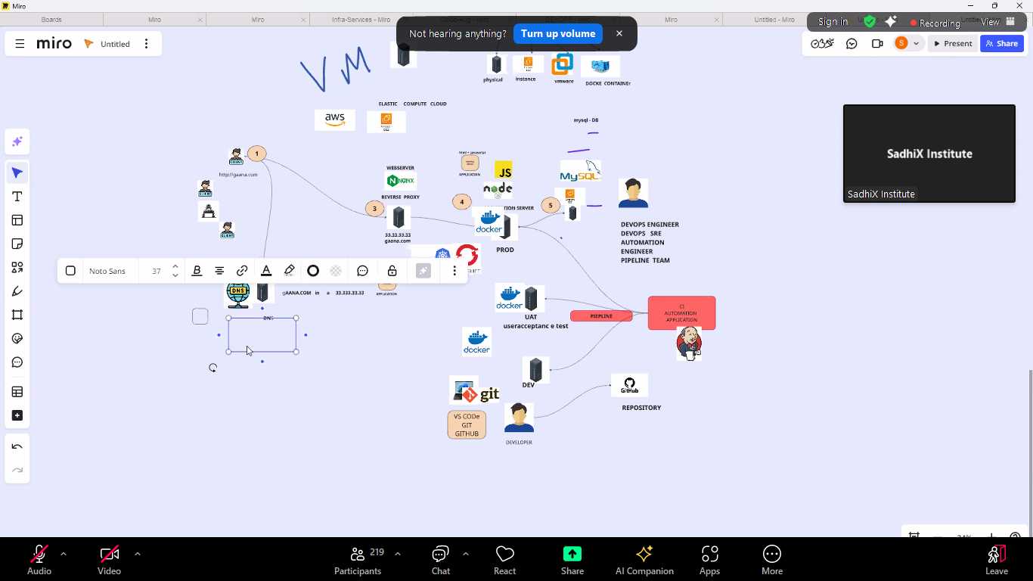

3rd TIER PROJECT PART 1 - DB (MARIADB)  
pre requisite -- create 2 instance 1-db , instance 2-appserver (nodejs)   
step 1 --   
apt install mariadb*  -y  
   
systemctl  restart  mariadb  
  
step 2 - create a database   
  
mysql  -u  root  -p (hit blank enter to login)  
  
CREATE DATABASE sadhixdb;

CREATE TABLE USER_INFO (  
    id INT PRIMARY KEY,  
    name VARCHAR(255),  
    username VARCHAR(255),  
    email VARCHAR(255),  
    street VARCHAR(255),  
    suite VARCHAR(255),  
    city VARCHAR(255),  
    zipcode VARCHAR(20),  
    lat VARCHAR(20),  
    lng VARCHAR(20),  
    phone VARCHAR(50),  
    website VARCHAR(255),  
    company_name VARCHAR(255),  
    company_catchPhrase VARCHAR(255),  
    company_bs VARCHAR(255)  
);

INSERT INTO USER_INFO (id, name, username, email, street, suite, city, zipcode, lat, lng, phone, website, company_name, company_catchPhrase, company_bs) VALUES

(1, 'Jobin A', 'Bret', 'Sincere@april.biz', 'Kulas Light', 'Apt. 556', 'Gwenborough', '92998-3874', '-37.3159', '81.1496', '1-770-736-8031 x56442', 'hildegard.org', 'Romaguera-Crona', 'Multi-layered client-server neural-net', 'harness real-time e-markets'),

(2, 'Zuber K', 'Antonette', 'Shanna@melissa.tv', 'Victor Plains', 'Suite 879', 'Wisokyburgh', '90566-7771', '-43.9509', '-34.4618', '010-692-6593 x09125', 'anastasia.net', 'Deckow-Crist', 'Proactive didactic contingency', 'synergize scalable supply-chains'),

(3, 'Nikhil P', 'Samantha', 'Nathan@yesenia.net', 'Douglas Extension', 'Suite 847', 'McKenziehaven', '59590-4157', '-68.6102', '-47.0653', '1-463-123-4447', 'ramiro.info', 'Romaguera-Jacobson', 'Face to face bifurcated interface', 'e-enable strategic applications'),

(4, 'Diler B', 'Karianne', 'Julianne.OConner@kory.org', 'Hoeger Mall', 'Apt. 692', 'South Elvis', '53919-4257', '29.4572', '-164.2990', '493-170-9623 x156', 'kale.biz', 'Robel-Corkery', 'Multi-tiered zero tolerance productivity', 'transition cutting-edge web services'),

(5, 'Rohit C', 'Kamren', 'Lucio_Hettinger@annie.ca', 'Skiles Walks', 'Suite 351', 'Roscoeview', '33263', '-31.8129', '62.5342', '(254)954-1289', 'demarco.info', 'Keebler LLC', 'User-centric fault-tolerant solution', 'revolutionize end-to-end systems'),

(6, 'Ketan V', 'Leopoldo_Corkery', 'Karley_Dach@jasper.info', 'Norberto Crossing', 'Apt. 950', 'South Christy', '23505-1337', '-71.4197', '71.7478', '1-477-935-8478 x6430', 'ola.org', 'Considine-Lockman', 'Synchronised bottom-line interface', 'e-enable innovative applications'),

(7, 'Omkar R', 'Elwyn.Skiles', 'Telly.Hoeger@billy.biz', 'Rex Trail', 'Suite 280', 'Howemouth', '58804-1099', '24.8918', '21.8984', '210.067.6132', 'elvis.io', 'Johns Group', 'Configurable multimedia task-force', 'generate enterprise e-tailers'),

(8, 'Bharat M', 'Maxime_Nienow', 'Sherwood@rosamond.me', 'Ellsworth Summit', 'Suite 729', 'Aliyaview', '45169', '-14.3990', '-120.7677', '586.493.6943 x140', 'jacynthe.com', 'Abernathy Group', 'Implemented secondary concept', 'e-enable extensible e-tailers'),

(9, 'Vidyanand J', 'Delphine', 'Chaim_McDermott@dana.io', 'Dayna Park', 'Suite 449', 'Bartholomebury', '76495-3109', '24.6463', '-168.8889', '(775)976-6794 x41206', 'conrad.com', 'Yost and Sons', 'Switchable contextually-based project', 'aggregate real-time technologies'),

(10, 'Manish L', 'Moriah.Stanton', 'Rey.Padberg@karina.biz', 'Kattie Turnpike', 'Suite 198', 'Lebsackbury', '31428-2261', '-38.2386', '57.2232', '024-648-3804', 'ambrose.net', 'Hoeger LLC', 'Centralized empowering task-force', 'target end-to-end models');

select * from user_info;

now set the password for db ---

ALTER USER 'root'@'localhost' IDENTIFIED BY 'Password@1234';

flush privileges;

quit;

command to check ports:

ss –tulnp

nano /etc/mysql/mariadb.conf.d/50-server.cnf

Sept 21

